Name: Meratun Junnut Anee

Id:1620527043

Title: **Air Quality Monitoring for Sustainable Systems via Drone Based Technology**

Publisher: **IEEE**

Date of publication: **2016**

Author: Josefa Wivou, Lanka Udawatta, Ali Alshehhi, Ebrahim Alzaabi, Ahmed Albeloshi and Saeed Alfalasi

Review:

This paper mainly did their work on a 3D space. They collected the sampling data for a given location and then analyzed the situation based on the air pollutants concentration and their patterns.They monitored it using a drone with the system installed. They stored the data on a cloud storage and kept record of it.

Drones have become a very familiar and fascinating technology that can be employed to collect data from an outdoor environment which is difficult for humans. So in this case to measure pollutant gases and other particles drone technology is a blessings.

Their system includes with:

* Drone and its remote control with a camera and display screen.
* Sensors and microcontrollers
* Real time reading and data storage in cloud
* Real time display on mobile device
* Monitored and viewed from anywhere
* Stored data is analyzed displayed on various monitors.

In this system there are different sensor technologies used for detecting various gases like O3, So2, Co2, CO, VOCs. Recent sensor technology is able to detect the level of these gases and find out the reasons. Their moto is to detect all kinds of pollutant gases and other elements emitted by human activities and other natural sources.

They used Arduino microcontrollers for data processing. Calibration of the sensors were also needed. All the sensors were connected to analog pins.

They used 3 MQ type sensorsfor monitoring CO, Co2, CH4.

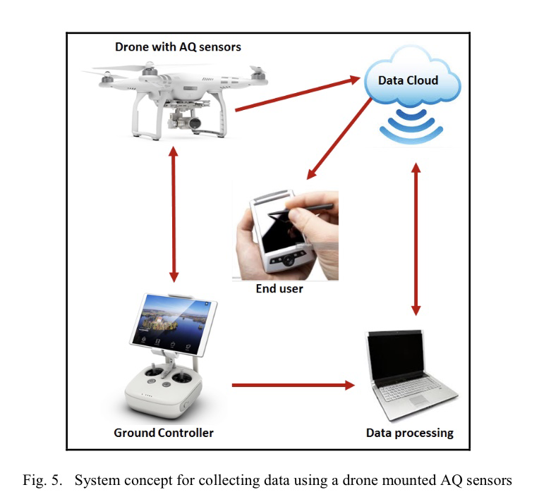

Advantage:

* Easy to built
* Maintenance cost minimum
* Easy to use
* Not expensive

Disadvantage:

* Sensitive System
* Connection and hardware system needs to be checked everyday.

Their system setup is currently experimented in Emirate of Ras Al Khaimah and could be used nationally and internationally. Sensors real time reading is processed through the arduino UNO microcontrollers and then stored on Blynk server. Then mobile app can display and base stations with GPS.

They used 3 axis stabilized camera and long range line view and 4k video recording option capabilities.